How to Downgrade Huddly IQ:

IMPORTANT NOTE BEFORE STARTING:

If the camera was updated through Windows Update and you perform this downgrade procedure, the camera will stay on 1.5.2 even if the engine goes through a reboot or power cycle. If the camera was previously upgraded manually, the engine will install the 1.5.4 upgrade driver which will trigger the upgrade

To validate that the Huddly IQ was upgraded manually or through Windows Update:
- Log in to the UC-Engine’s admin settings.
- Navigate to “Device Manager”
- Navigate to “Universal Bus Controllers”
- Locate the “Huddly IQ” device (sometimes called “Huddly IQ with Mic”)
- Under the “Driver” tab you will see the driver version: 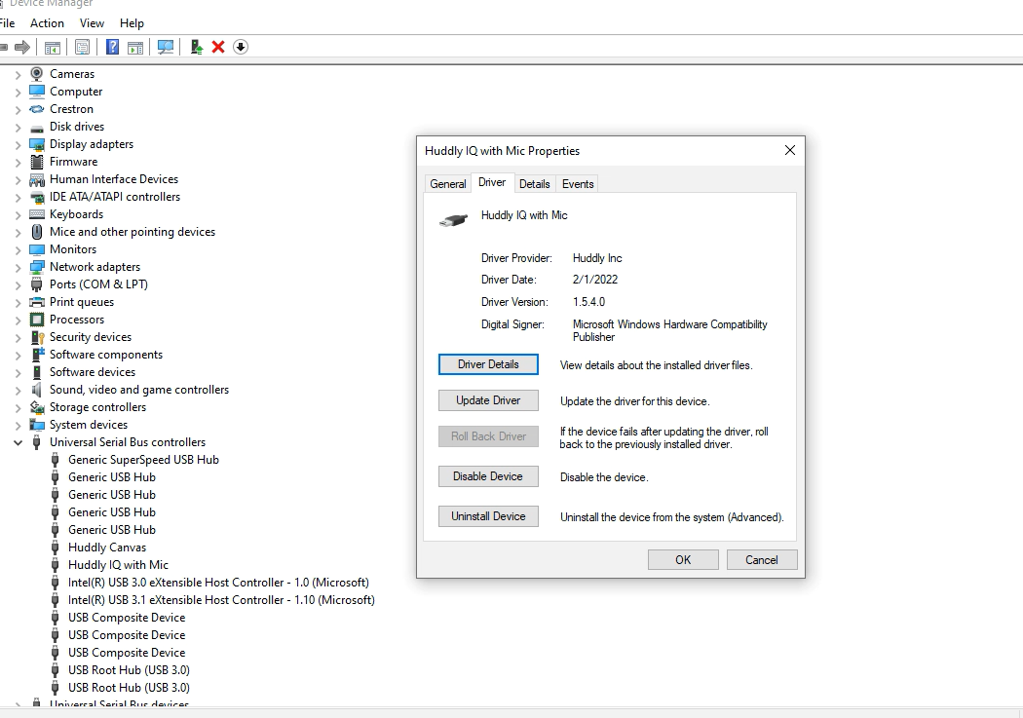
  - If the driver version is older than 1.5.4, then Windows Update will upgrade the camera after reboot/power cycle after completing
  - If the driver version is on 1.5.4, the camera will stay on 1.5.2 after reboot/power cycle
Downgrade Process:
- Disconnect Huddly IQ from the engine and connect the USB-A cable to laptop
- Download the “CollectHuddlyLogsOnPC.zip” & “Crestron-upgrader-1.5.2-115226.zip” files from this link: https://crestron.filecloudonline.com/url/huddlydowngrade (Password: huddlyiq)
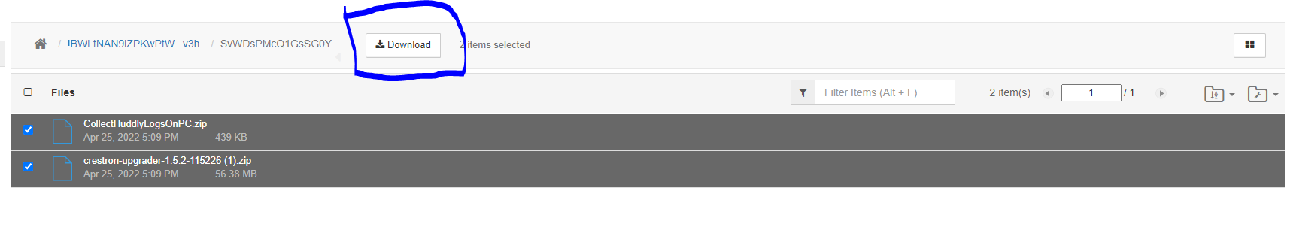
- Verify that the Huddly App is NOT running on your laptop
- Clear the logs of the Huddly IQ using “CollectHuddlyLogsOnPC” file
  - When clearing logs, make sure the Huddly app is not running
  - Extract the zip file and run the “CollectHuddlyLogsOnPC.bat” file
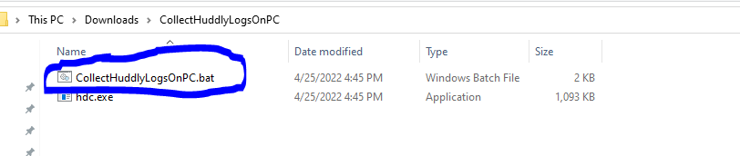
Note: When running the batch file, a command prompt window will automatically open and clear the logs. Once it is done you will see a green screen like so:
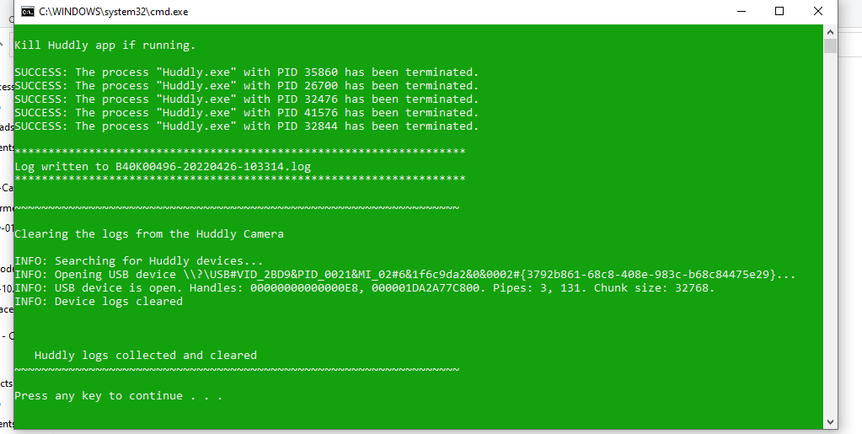

- Downgrade the camera to 1.5.2 using “Crestron-upgrader-1.5.2-115226” file
  - Extract the zip file and run the “upgrader.exe” from the folder
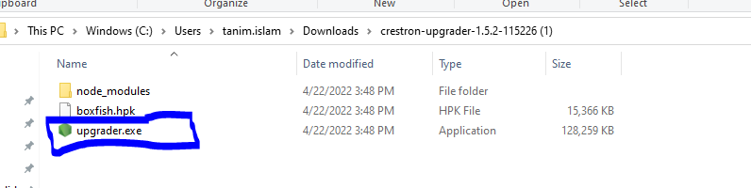
Note: When running the upgrader.exe file, the FW installation will open the following window and will automatically close after the installation is complete (approximately takes 1-2 minutes): 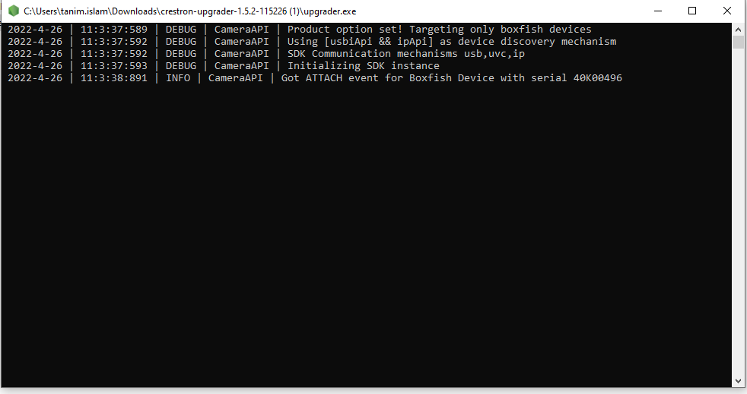

- Verify Huddly IQ FW version
  - Via Huddly App: Click on the settings tab on the top left corner of the app window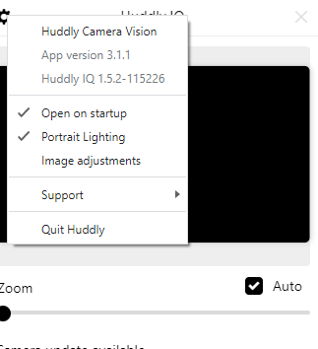
  - Via XiO: Connect Huddly IQ back to UC-Engine, go to the respective UC-Engine on XiO Cloud, and select the peripherals tab
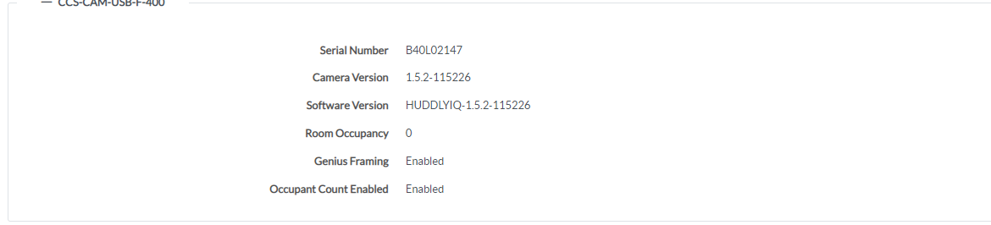
  - Via Crestron Setting: Connect the Huddly IQ back to UC-Engine. Enter Admin mode, navigate to Crestron Settings, under Systems -> System Devices -> Camera, you will see the current FW version of the Huddly IQ
