Poly MTR & GC8 FAQ
Contents
Poly MTR & GC8 FAQ 1
Common Issues and Workarounds 1
Does the headset jack support microphone and speaker (3.5 mm connector)? 1
How to Remotely connect to the MTR? 1
What can cause issues with an MTR after MTR is scheduled to a meeting and having issues getting access to the meeting? 1
Device Admin cannot run their Powershell commands, why? 1
Sometimes the application loads and the screen gets disconnected as shown in the picture below 1
What is the external wiring diagram for Lenovo and GC8 for the MTR? 1
FAQ 1
Where to find Microsoft certified MTR Devices and Room Systems? 1
What is the MTR default admin password? 1
How do the external devices get updated? 1
Is the Poly Trio C60 qualified by Microsoft to work on the Poly G80-T for Medium to Large Rooms? 1
Does the MTR support Wireless for Video Conferencing? 1
What are the three account configurations to setup a Microsoft Team Room? 1
Will the MTR support Teams and Skype For Business? 1
What other commands do you need to run to allow third party invitations to be automatically accepted? 1
What size is the LCD on the Poly MTR Console (GC8)? 1
What type of I/O ports are on the Poly MTR console (GC8)? 1
Is there a Proximity Sensor located on the Poly MTR console (GC8)? 1
Is there a Kensington lock on the MTR console (GC8)? 1
How does the installer get access to the cables on the MTR console (GC8)? 1
Is there a cable diagram that can be followed to install the MTR? 1
Where are the logs located for the MTR console (GC8)? 1
What is the Directory limit on the Poly MTR console (GC8)? 1
How do you pull all the logs from the MTR? 1
Where do I find the Lenovo Serial Number? 1
Where do I find the MTR console (GC8) serial number? 1
How to access the system information? 1
Are there any other Teams Room Training classes offered by Microsoft? 1
What is the EED II Accessory/cable kit part number? 1
How to enable and disable the EEII auto tracking when installed on the MTR? 1
On a G80, which device is used for Audio Out. Monitor via HDMI or the C60? 1
Once I log into the Windows Settings using the Admin account, how do I exit out to go back to the normal screen? I only get the options to Sleep, Shutdown or Reset. 1
How to remove the back cover on the GC8? 1
Does the MTR with the Studio Bar support 4K video? 1
Is Push Button Reset supported? 1
Can Zoom and/or WebEx Meetings be enabled on MTR? 1
Where is the Enable White boarding setting? 1

Common Issues and Workarounds

Does the headset jack support microphone and speaker (3.5 mm connector)?
Ans: Yes but will not automatically work. Must go into settings → and change the devices to the headset

How to Remotely connect to the MTR?
Ans: Ans: Install a program called "TightVNC". It is a program to remote into the MTR. Install the server on the MTR and then you can use the viewer on your remote PC. Do NOT use the Remote Desktop Protocol. If used, it will lockout the PC and it will not show you all the displays. RDP does work but there will be issues. RDP is disabled by default. Link to download the software can be found here → https://tightvnc.com/

What can cause issues with an MTR after MTR is scheduled to a meeting and having issues getting access to the meeting?
Ans: The MTR must be logged in with a Resource Room Account ONLY. A user account cannot be used.
Device Admin has not run the Powershell command on that MTR. The PowerShell command is found here → https://docs.microsoft.com/en-us/microsoftteams/rooms/with-office-365
The Powershell command is Set-CalendarProcessing -Identity "Rigel-01" -AutomateProcessing AutoAccept -AddOrganizerToSubject $false -DeleteComments $false -DeleteSubject $false -RemovePrivateProperty $false -AddAdditionalResponse $true -AdditionalResponse "This is a Skype Meeting room!"
In Exchange Online PowerShell, configure the following settings on the room mailbox to improve the meeting experience:
- AutomateProcessing: AutoAccept (Meeting organizers receive the room reservation decision directly without human intervention: free = accept; busy = decline.)
- AddOrganizerToSubject: $false (The meeting organizer is not added to the subject of the meeting request.)
- DeleteComments: $false (Keep any text in the message body of incoming meeting requests.)
- DeleteSubject: $false (Keep the subject of incoming meeting requests.)
- RemovePrivateProperty: $false (Ensures the private flag that was sent by the meeting organizer in the original meeting request remains as specified.)
- AddAdditionalResponse: $true (The text specified by the AdditionalResponse parameter is added to meeting requests.)
- AdditionalResponse: "This is a Skype Meeting room!" (The additional text to add to the meeting request.)

Device Admin cannot run their Powershell commands, why?
Ans: The Device Admin must install and run the following commands before running the specific MTR commands → http://blog.schertz.name/2019/02/creating-microsoft-teams-rooms-accounts/

Sometimes the application loads and the screen gets disconnected as shown in the picture below
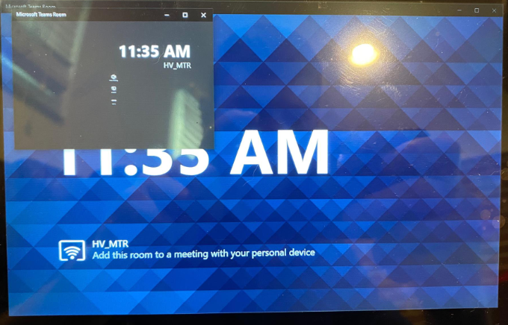
Ans: Unplug the screen and plug back in

What is the external wiring diagram for Lenovo and GC8 for the MTR?
Ans: 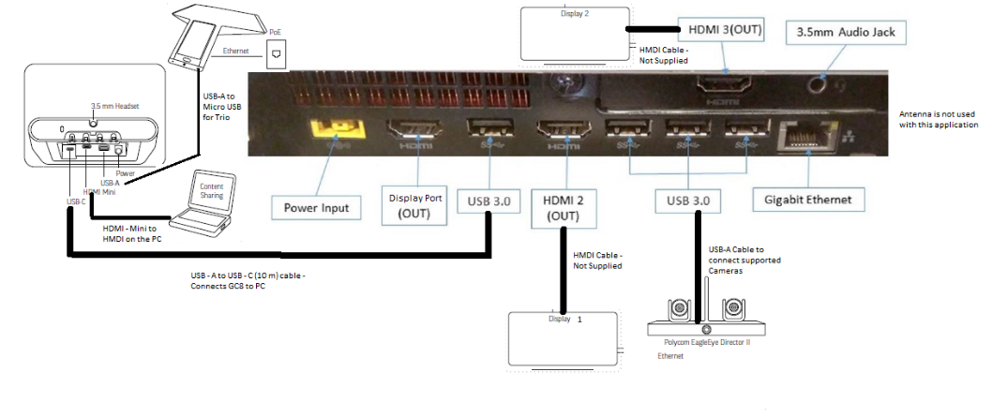

FAQ

Where to find Microsoft certified MTR Devices and Room Systems?
Ans: https://www.microsoft.com/en-us/microsoft-365/microsoft-teams/across-devices/devices/category?devicetype=20
EagleEye USB is not yet certified by Microsoft so it is not supported yet. Coming Soon

What is the MTR default admin password?
Ans: sfb (this should be changed by the device admin to meet security requirements)

How do the external devices get updated?
Ans: If the device (Camera, microphone, etc.) is certified by Microsoft, then the update can be done by Microsoft by Windows Update

Is the Poly Trio C60 qualified by Microsoft to work on the Poly G80-T for Medium to Large Rooms?
Ans: Currently the Poly Trio C60 is NOT certified by Microsoft as an MTR device (coming soon)

Does the MTR support Wireless for Video Conferencing?
Ans: No, An Ethernet connection is required

What are the three account configurations to setup a Microsoft Team Room?
Ans: Accounts need to be licensed and configured correctly, refer to https://docs.microsoft.com/en-us/microsoftteams/rooms/rooms-configure-accounts
- Online deployment: Your organization's environment is deployed entirely on Office 365. For more information, see Deploy Microsoft Teams Rooms with Office 365.
2. On-premises deployment: Your organization has servers that it controls, where Active Directory, Exchange, and Skype for Business Server are hosted. For more information, see Deploy Microsoft Teams Rooms with Skype for Business Server
3. Hybrid deployments: Your organization has a mix of services, with some hosted on-premises and some hosted online through Office 365. With Microsoft Teams Rooms, the following hybrid scenarios are supported:
- Exchange Online with Skype for Business Server on premises. For more information, see Deploy Microsoft Teams Rooms with Exchange Online (Hybrid).
- Exchange on premises with Microsoft Teams or Skype for Business Online. For more information, see Deploy Microsoft Teams Rooms with Exchange on premises (Hybrid).

Will the MTR support Teams and Skype For Business?
Ans: Yes, there is a setting under "Account" where you can select "Skype for Business Only" or "Skype For Business and Microsoft Teams". Skype for Business Online is still supported by Microsoft until June of 2021 as stated by Microsoft. To setup a Skype For Business account for your MTR, go to https://docs.microsoft.com/en-us/microsoftteams/rooms/with-office-365 or you can access Jeff Schertz web page for additional information → http://blog.schertz.name/

What other commands do you need to run to allow third party invitations to be automatically accepted?
(Example: If you forward your Poly meeting to the MTR, it will not get processed)
Ans: -ProcessExternalMeetingMessages
The ProcessExternalMeetingMessages parameter specifies whether to process meeting requests that originate outside the Exchange organization. Valid values are:
- $true: Meeting requests from external senders are processed.
- $false: Meeting requests from external senders are rejected. This is the default value.

What size is the LCD on the Poly MTR Console (GC8)?
Ans: 8 inch - 1280 x 800

What type of I/O ports are on the Poly MTR console (GC8)?
Ans:
- 3.5mm Headset jack accessibility
- Power input
- USB 3.0 Type-A – peripheral support i.e. Trio
- Mini-HDMI video Input – 1080p 30fps
- USB 3.0 Type-C – to front of room PC
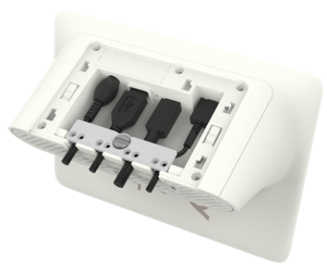

Is there a Proximity Sensor located on the Poly MTR console (GC8)?
Ans: Yes, and the sensor is used to wake up the MTR connected monitor when someone gets close to the MTR console

Is there a Kensington lock on the MTR console (GC8)?
Ans: Yes

How does the installer get access to the cables on the MTR console (GC8)?
Ans: There is are two Philips-head screws on the bottom that must be removed to get access to the cables. The Philips screw driver is not provided.

Is there a cable diagram that can be followed to install the MTR?
Ans: Yes, see below
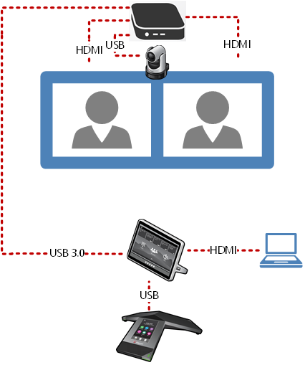

Where are the logs located for the MTR console (GC8)?
Ans: The logs are located at C;\Program Files\Poly\Log

What is the Directory limit on the Poly MTR console (GC8)?
Ans: 100mb

How do you pull all the logs from the MTR?
Ans: To pull complete log package execute: powershell -ExecutionPolicy unrestricted
c:\rigel\x64\scripts\provisioning\ScriptLaunch.ps1 CollectSrsV2Logs.ps1

Where do I find the Lenovo Serial Number?
Ans: Serial number can be found on the bottom of the Lenovo computer

Where do I find the MTR console (GC8) serial number?
Ans: The serial number can be found on both the bottom cover and within the cable run area

How to access the system information?
Ans: Use the QR code on the bottom of the Lenovo computer and/or find the details when logging into the Windows 10 PC

Are there any other Teams Room Training classes offered by Microsoft?
Ans: https://www.microsoftevents.com/profile/web/index.cfm?PKwebID=0x1934163abcd

What is the EED II Accessory/cable kit part number?
Ans: 2215-69443-001 - EagleEye Director II ACCESSORY KIT, MSR and PC, 1x 5m HDMI cable, 1x 1.8m HDMI cable, 1x 5m USB cable, 1x remote control and 2x AAA batteries.

How to enable and disable the EEII auto tracking when installed on the MTR?
Ans: Companion App does not connect to the EEDII, you must use the webui interface or the EEDII App.

On a G80, which device is used for Audio Out. Monitor via HDMI or the C60?
Ans: You can switch audio devices within the MTR settings. Settings → Peripherals → Audio

Once I log into the Windows Settings using the Admin account, how do I exit out to go back to the normal screen? I only get the options to Sleep, Shutdown or Reset.
Ans: If you click on the user icon on the top, it gives you the option to sign out, when you sign out, just click the Skype user again then click sign in
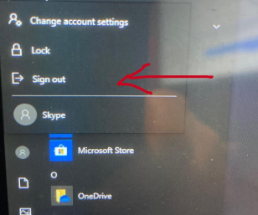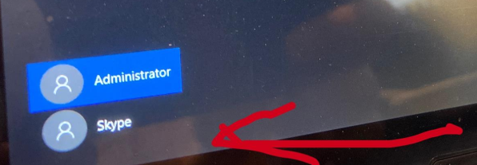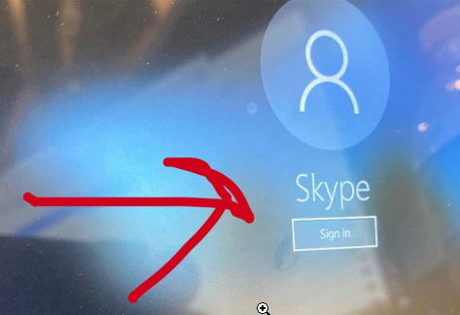

How to remove the back cover on the GC8?
Ans: Remove the bottom screw and press left and right side of the cover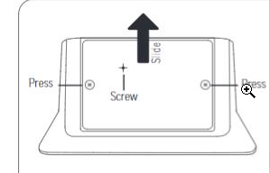

Does the MTR with the Studio Bar support 4K video?
Ans: Microsoft Teams does not support 4k yet. The maximum tested was 1080p.
Link from Microsoft →
https://answers.microsoft.com/en-us/msteams/forum/all/camera-resolutions-supported-by-microsoft-teams/2694384d-b0eb-4312-9e64-d87fcc6df65d

Is Push Button Reset supported?
Poly MTR supports Windows Push Button Reset (PBR) functionality. This feature restores the MTR to its factory state. To reset the MTR to factory state,
- Connect an external keyboard to the MTR via one of the USB ports
- Restart the MTR or power-off and power-on the MTR, at the beginning of the boot process keep tapping on the F11 key on the keyboard. This will open the Windows Recovery Environment.
- Select “Troubleshoot”
- Select “Reset this PC”
- Select “Remove everything” Note: Recovery via “Keep my files” is not supported.
- Select “Just remove my files”
- Click on “Reset” At this point, the process of resetting the MTR to its factory state will begin. Please do not power off or restart the MTR. The entire process may take a few hours. Once complete, the MTR will be restored to its original factory state.

Can Zoom and/or WebEx Meetings be enabled on MTR?
Yes, see the screen shot
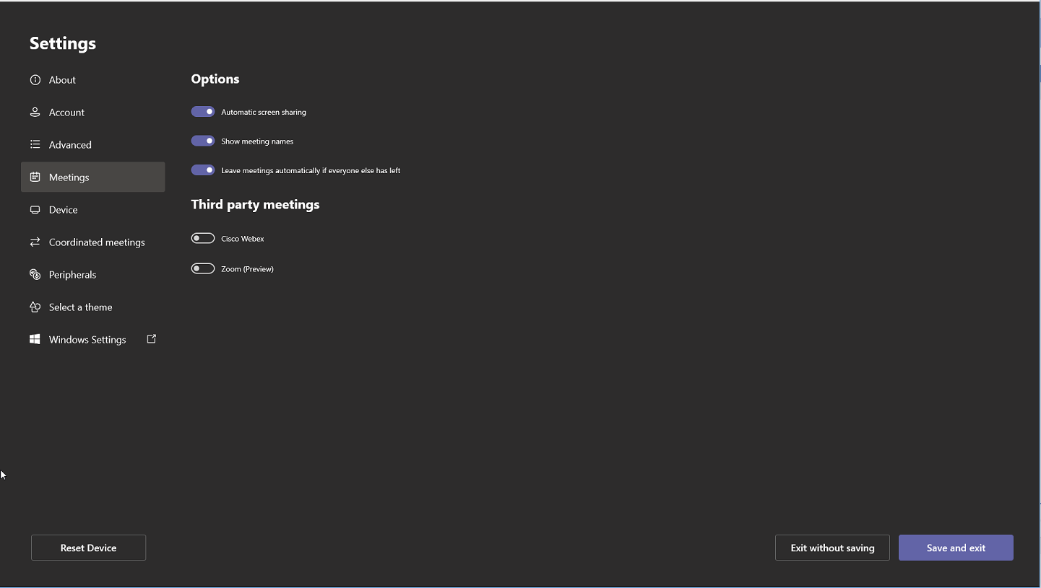

Where is the Enable White boarding setting?
