Please find here below the procedure to reimage the MTR Intel NUC including the latest MTR available image download link
Logitech Microsoft Teams Room NUC Recovery Image Information
Before you begin
● IMPORTANT: The computer must have gone through OOBE while connected to the internet and must show that the Windows is activated. If you try to re-image the system before it is licensed, the NUC will need to be replaced.
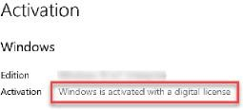
- Only use this recovery media on your Microsoft Teams Room Rev 1 (NUC8i5BEH, NUC8i7BEH) or Rev 2 (NUC11TNKi5)
● These instructions are intended to create boot media to recover the Microsoft Teams Room NUC.
● THE USB DRIVE NEEDS TO BE WIPED AFTER THE INTEL NUC IS REIMAGED.
You will need:
● A USB stick formatted as FAT32
● The USB stick should be large enough to contain the (unzipped) recovery media 18GB
● It is strongly recommended that you use the fastest USB media (USB 3.1) available to you, to minimize the time the re-imaging process takes.
● A USB Keyboard
Determine the recovery media
There are two different hardware platforms, depending on which REV you have, you need to download the correct recovery image. Using the wrong recovery media will prevent the system from running optimally.
REV 1 – On the bottom of the NUC there is no sticker clearly identifying the Rev version
REV 2 – On the bottom of the NUC there is a sticker indicating you have a REV2 device. Followed by V211 or V213
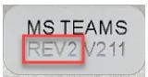
IMPORTANT: If your NUC has the following sticker on the bottom contact Logitech support. If you install the media provided with these instructions, you will lose the Windows licensing.
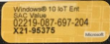
Download the Media
- REV 1
- REV 2
To recover your NUC:
1. Plug the USB stick you wish to use into your desktop/laptop computer.
2. Right-click the USB stick, and select "Format..."
3. Use the "File system" drop-down to select "FAT32"
4. Click "Start"
5. Extract the recovery ZIP file to the root of your USB stick
a. If the files are unzipped into a single sub-folder on the USB stick, the recovery will not work; you will need to move them out of that sub-folder and into the root of the USB drive.
b. You should see a file restore_*.swm at the top level of the drive.
6. Eject your USB stick from your desktop/laptop computer
7. If your NUC is not already powered off, power it off now by pressing and holding the power button.
8. Connect the USB keyboard.
9. It is recommended to remove all room equipment except the keyboard from your NUC except the Front of Room display(s).
10. Plug your USB stick directly into a blue USB port. Do not use a black port.
11. At the POST boot prompt, press F10 to enter the boot menu
12. From the boot menu choose the USB drive
13. Get a cup of coffee, the imaging process can take some time.
14. Once the restoration process has completed, the system will reboot automatically.
15. Connect your room equipment.
16. After device installation is complete, Windows OOBE will start. The system will now be ready for installation/configuration for use in your environment.
17. IMPORTANT: If you made any BIOS changes, press F2 to enter BIOS and revert any changes made.
While failure to revert changes will not affect imaging process, it may cause boot issues later.
18. Disconnect the keyboard
If the system fails to boot from the USB drive
REV 1 NUC
At the POST screen Press F2 to enter the BIOS. If this fails, you will need to plug in your keyboard to the USB-C Port with an adapter.
1. Click on the Advanced Tab
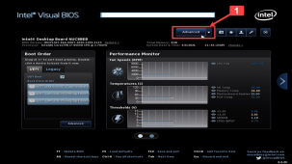
2. Click on Devices
3. Click on USB
4. On the right side select the port that has the USB drive connected, (do not enable all ports) and set the connection to enabled.
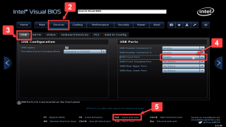
5. Press F10 to save the settings and Reboot
Rev 2 NUC
At the POST screen Press F2 to enter the BIOS. If this fails, you will need to plug in your keyboard to the USB-C Port with an adapter.
- Click on Advanced
- Click on USB
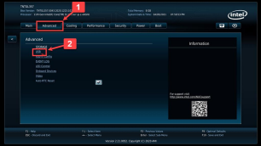
3. Select the port that has the USB drive connected, (do not enable all ports) and set the connection to
enabled
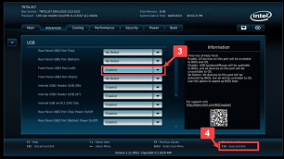
4. Press F10 Save the settings

